Exeter Chess Club Annual General Meeting

Held at 7.15 pm on Tuesday 17 September 2019 at the Heavitree Social Centre, 2 East Wonford Hill, Heavitree.
MINUTES
Members presents: Chris Lowe, Tim Paulden, Sean Pope, Paul O’Neill, Jeremy Amos, Graham Bolt, Richard Player, John Guard, Roy Hedges, Tony Hedges, Tom Thorpe, Brian Aldwin, Richard Scholes and John Maloney.
.
1. Apologies Dave Regis and Tim Starkey.

2. Minutes of previous AGM, matters arising: No matters arising. The AGM voted to accept the minutes of the previous AGM as accurate.

3. Reports of officers on season 2018-19. Tim Paulden (President) mentioned that the club had a pretty successful season and reported on the external competitions. Devon CCA league competitions: Exeter won a hard fought Bremridge (Div 1) competition once again and Tim congratulated the captain Graham Bolt. Exeter & District league competitions: Exeter Rooks were runners up in the Premiership (Div 1) and Exeter Gambits were runners up in the Championship (Div 2). Once more Exeter won the top section Thomas trophy at the Devon CCA quickplay team tournament at Newton Abbot. Tim Paulden has reached the final of the Champion of Champions Thomas Winter-Wood Shield competition. Tim presented the trophies in respect of the internal and external competitions and congratulated all the winners. It was also reported that the Douglas-Phillips Lightning tournament took place and was won by Graham Bolt. A Christmas variant/blitz competition also took place.

Paul O’Neill (Tournament secretary) See attached report below.

Dave Regis (Junior Club and Information Officer) See attached report below which was read out at the AGM.

Jeremy Amos (Equipment Officer) reported that we have adequate equipment which functions properly. Jeremy requested that matchboards and equipment are not borrowed from the match bag without letting him or another committee member know.

4. Election of officers for the coming season. The following officers agreed to stand again Tim Paulden (President), Sean Pope (Secretary), John Maloney (Treasurer), Paul O’Neill (Tournament Secretary), Dave Regis (Junior Club), Dave Regis (Information Officer) and Jeremy Amos (Equipment Officer). All those standing were elected unanimously to the posts. The Auditor role has been kindly carried out this season by an external auditor Dr Gary Abrahams.

5. Statement of finances: Setting of membership fee for 2019-2020. John Maloney (Treasurer) presented the 2018-19 accounts to the AGM. The accounts showed that the club has made a surplus of £302.79 in the 2018-19 season. John mentioned that there had been no big items of expenditure and the sale of the last of the club library produced some income. The current account balance is £1999.85. The club has a five year investment of £12,500 with the Skipton Building Society which comes to an end in May or June 2020. The committee will decide at the time where the money is to be newly invested. The accounts have been audited. John proposed that the annual club subscription should be remain as £5 for all members. This proposal was passed unanimously by the meeting.

6. Organisation of club internal competitions and selection of teams for league competitions. Paul O’Neill (Tournament Secretary) asked if members could sign up as soon as possible for the club championship and rapidplay. The championship will keep the same 6 round swiss pairing format. Graham Bolt suggested that the rapidplay should have a two stage format. After discussion a swiss paired rapidplay was proposed instead and the meeting voted for this proposal with one objection.

The members were reminded that those players wishing to play in the club’s internal graded competitions or in external leagues representing the club must have at least a current ECF bronze membership.

The captains of the league teams were agreed as follows: DCCA League Bremridge Div.1 Graham Bolt, Newman rapidplay one day event captain Tim Paulden.

Exeter & District League Premiership (team under ECF 640) Exeter Rooks Tim Paulden. Exeter & District League Championship (team under ECF 480) Exeter Gambits Brian.Aldwin. Rapidplay (team under ECF 560) Exeter Prestissimo John Maloney. Exeter Gambits Rapid Jeremy Amos.

Members were invited to sign up for the league competitions.

7. AOB. The AGM agreed with one vote against that the club’s ECF insurance including public liability cover should be renewed. The Chess Devon website is no longer being updated as the webmaster Bill Frost sadly passed away. Tim Paulden reported that he has set up a new free website DevonChess.com complete with chess calendar.

Jeremy mentioned that the committee will be chasing the £5 chess club annual membership fees. An online payment option may be set up for those who prefer to pay that way. The committee will also check that members have renewed their Heavitree Social Centre membership due at the end of September (£18 a year with reduced amount for people over 60 and unemployed).

The British Chess Championships took place at Torquay in July/August 2019. Tim impressively finished third in the rapidplay competition there.

It was reported that 2020 is the 125th anniversary of the club and it will be marked by either a simultaneous event or special tournament with a buffet possibly subsidised by the club.

Tom Thorpe reported that an ECF arbiter course is being run in Exeter on 05.10.2019 and 06.10.2019 and those interested should contact Tom or visit the ECF website.

Jos Haynes mentioned the need for more external promotion of the club eg by a newspaper article linked to the 125th anniversary of the club. It was also suggested that more promotion on social media or chess.com should be explored.

The following dates were agreed for the start of the season:
01.10.2019: Simultaneous match (7.15pm) by club champion Paul O’Neill.
Date to be confirmed: Christmas Chess Variants tournament.
Date to be confirmed in 2020: Rex Willis Gambit Tournament
Date to be confirmed in 2020: Douglas Phillips Lightning tournament.

Sean Pope, Exeter Chess Club secretary, 22.09.2019

Exeter Chess Club – Tournament Report by Paul O’Neill

Club Championship
The club championship promised to be close this year with 6 players above 170 grade. It all came down to the final round with seven players in with a chance of winning the title, and the possibility of a 6-way tie. Perhaps inspired by the prospect of organising the play-off throughout the summer, I (Paul) managed to win and maintain and my half point lead. Perhaps the decisive moment was against Tim in round 5, with a (very easy to miss) win on the board, Tim let his clock run down to one second, but could not quite find the win.

Congratulations to Tim (second) and Jeremy (third) the latter also winning the general (u145) section.

Mentions to Ian, Jake, Jeremy and Richard Scholes who took points from much stronger opponents. And to David (Shotter) in his first tournament was one of the 7 players in with a shout at the end.
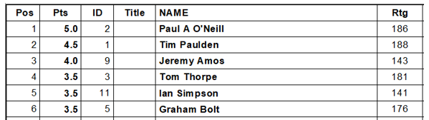
Rapidplay Championship
As with the main championship, the rapid play title went down to the last few games, with Jos, Graham and myself with a chance of the title on the last evening of the competition.

Congratulations to Graham who won through, undefeated in his 10 games. Jos finished second and I was third.
Laudatory mentions to Brian, Jake and Stefano who won against players more than 40 points higher.

Game completion rate was 43%
Full cross-table below

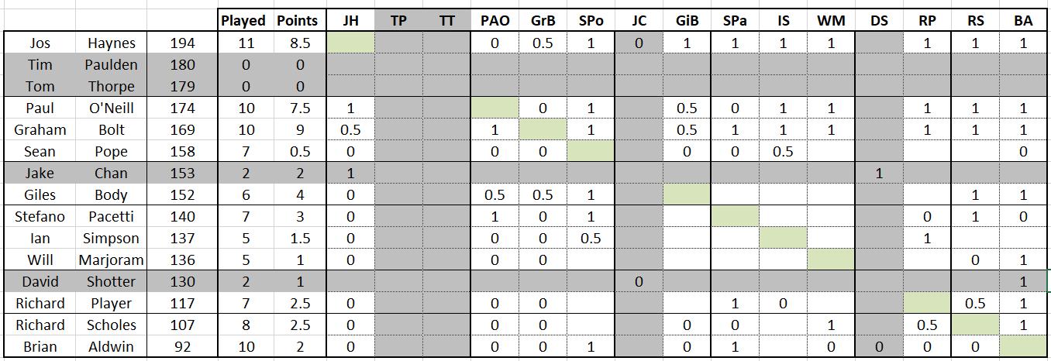
Exeter and District Leagues.
Congratulations to Exmouth Eagles, who triumphed in the Premiership (scoring 6 points out of a possible 8) and take home the coveted Cottew Cup. Hot on their heels (with 5 points out of 8) were Exeter Rooks, who receive the Turner Cup.

Congratulations also to Colyton Grammar School, who won this season's Championship - and the Polsloe Cup - in a board-count tie-break with Exeter Gambits, after both teams finished level on 6 points out of 8. Exeter Gambits receive the Mainstay Cup in recognition of this strong second-place finish.
Finally, congratulations to Exmouth Egrets, who won the Rapidplay league with a magnificent score of 22 points out of 25.

AGM reports from Dave Regis
1. Junior Club
The Exeter Junior Chess Club has begun its 26th year in its current run, ably supported by David Beckwith and occasional others, meeting on Fridays between September and May. David has returned, after managing the club himself for many years before I stuck in my nose, to provide a
great deal of invaluable help and leadership. Membership is modest but chirpy; I think the most we had any night last year was 14, but half that is more typical.

Last season, several members won prizes in local Devon competitions and competed for Devon in the annual jamboree. We also had prizewinners in local and national stages of the UK Chess Challenge (often referred to as the 'Megafinal'), and some brave souls entered the British Chess
Championships in Torquay this August, with mixed results. We will be writing to Exeter secondary schools this Autumn to try and attract a few more members.

2. Information officer
My role as Information Officer has been carried out mostly by keeping an eye on the website and online calendar. Comments on both are invited. I have usually added reports to the website for matches I have organised, and would be pleased to add reports from others; when you send
results in to the East Devon or Devon Leagues, why not send me a copy too? Games too are always welcome. The calendar I maintain is in Google format so you may be able to integrate it with your phone or other systems.
If there's anything else that an information officer should be doing, please let me know. What should be on the notice board?

3. Coaching
I sent my usual invitation to members for suggestions of coaching sessions to happen during the quiet Summer period, but received nothing, and chose not to inflict any topics of my own choosing upon the club. I can run sessions in Summer 2020 if members would like; similarly, I'm happy to support volunteers who want to run sessions themselves. Notes from previous coaching sessions are on the website.

I have a standing invitation to anyone to submit a game score to me for constructive comment, and would be happy to chat to anyone who thinks they would like an MOT for their chess.

4. President's Cup
I was proud to be awarded this year's DCCA President's Cup for services to chess. The work I do relies entirely on the rest of the Devon Junior Chess Association committee and our events work well only because parents help out on the day, so I would like to take this opportunity to thank all those involved.

5. AOB for the committee
a. I can set up online payment for membership fees, if so desired. We collect entry fees for Devon Junior events using PayPal; you don't need a PayPal account to use it, but you do need a card.

b. I have offered the remains of the library, unbound magazines, to Channings Wood prison, which had a visit earlier this year from the ECF Director of Prisons Chess, hoping to sustain their interest.

